A13-Eur-England-Kent-Northfleet near Swanscombe-Clactonian Biface- 424,000 – 400,000 BP

 

Fig, 1. England-Kent-Northfleet near Swanscombe-Clactonian Biface-Dorsal view-424,000 – 400,000 BP

Fig. 2. A reconstruction of *Homo erectus* at the Westfälisches Landesmuseum, Herne, Germany, in a 2006 exhibition. From <https://upload.wikimedia.org/wikipedia/commons/thumb/c/cb/>

Homo_erectus_new.JPG/200px-Homo_erectus_new.JPG

Fig. 3. England-Kent-Northfleet near Swanscombe-Clactonian Biface-Ventral view-424,000 – 400,000 BP

**Formal Label:** England-Kent-Northfleet near Swanscombe-Clactonian Biface -424,000 – 400,000 BP

**Display description:**

Clactonian refers to the flint tools found in a paleo-channel at Clacton-on-Sea in Essex, England, in 1911 (Warren 1922). The present tool was found in the Northfleet area, near the destroyed flint quarries of Barnfield Pit and Rickson's Pit, Swanscombe, Kent County, England, previously noted for their Clactonian artifacts (Tester 1984).

This Clactonian flint tool was made by *Homo erectus* in the early Hoxnian Interglacial, Marine Isotope Stage 11, 424,000 BP-374,000 BP (Lisiecki and Raymo 2005; Stringer 2006) and may have been used for processing meat from Pleistocene animals including the straight-tusked elephant *(Palaeoloxodon antiquus*) (Glass 2016) and the giant hippopotamus, (Hippopotamus amphibius) (Schreve 2009**;** Tester 1984).

**Accession Number: A13**

**LC Classification:** GN772.22.G7

**Date or Time Horizon:** 424,000 – 400,000 BP

**Geographical Area:** Northfleet near Swanscombe, Kent

**Map, GPS Coordinates:** 0.33694, 51.441072; 51° 26' 27.859" N 0° 20' 12.984" E.

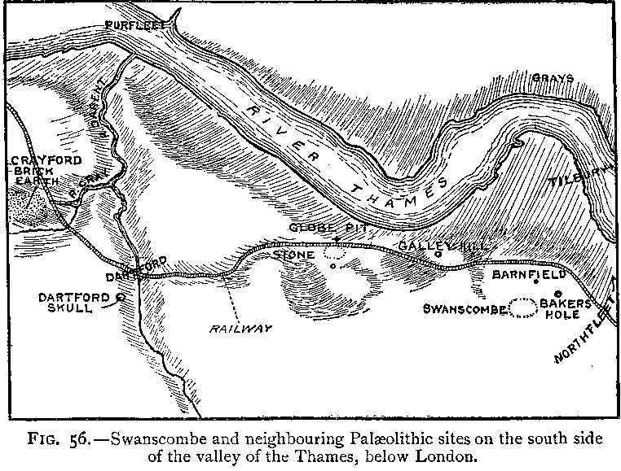

Fig.3. “Swanscombe and neighboring paleolithic sites on the south side of the valley of the Thames, below London,” after Keith 1916, Fig. 56.

Fig. 4. Map of Swanscombe and Northfleet on the south side of the valley of the Thames, below London, up to 1996, where Paleolithic peoples sought flint in the chalk outcrops and areas of quarries. After [LinguisticDemographer](https://en.wikipedia.org/wiki/User:LinguisticDemographer) at [English Wikipedia](https://en.wikipedia.org/wiki/).

**Cultural Affiliation:** Lower Paleolithic, Clactonian

**Medium:** Flint

**Dimensions: H 18 cm; W 11 cm.  
Weight: ca 1133.98 gm, 2.5 lb**

**Provenance: Old English collection of flint artifacts from field walking the Sweanscombe area from 1920’s**

**Condition:** original with ancient patination.

**Discussion:** This Clactonian biface, 424,000 BP-374,000 BP found near Swanscombe, Kent, has been flaked from a thick elongated flint cobble and has been bifacially worked to form a robust distal point. The dorsal side retains a large cortical area at the proximal end; this cortical area continues along the right lateral edge and around the proximal end which is naturally rounded, being the surface of the flint cobble. The ventral side has been finished with retouches to the distal end. The prominent bulb of percussion on the flakes indicates use of a hammerstone for more controlled and regulated shapes than was possible with the Olduwan technology.

**References:**

Conway, Bernard, John McNabb and Nick Ashton, eds.. 1996. *Excavations at Barnfield Pit,* *Swanscombe, 1968-72*; illustrations by Phil Dean. London: Dept. of Prehistoric and Romano-British Antiquities.

Glass, Helen. 2004. “Stone Age elephant remains found,” BBC News, 19 June. <http://news.bbc.co.uk/2/hi/uk_news/england/kent/3821527.stm>. Retrieved 1 Feb 2017.

Keith, Arthur. 1915. *The Antiquity of Man*. London.

Lisiecki, Lorraine E. and Maureen E. Raymo. 2005. “A Pliocene-Pleistocene stack of 57 globally distributed benthic δ18O records,” <http://www.lorraine-lisiecki.com/LR04_MISboundaries.txt>. Retrieved 1 Feb 2017.

## McNabb, John. 2007. *The British Lower Palaeolithic: stones in contention*. London, New York: Routledge.

# Schreve, Danielle C. 2009. “A new record of Pleistocene hippopotamus from River Severn terrace deposits, Gloucester, UK—palaeoenvironmental setting and stratigraphical significance,” *Proceedings of the Geologists' Association*, 120 (1): 58–64.

Stringer, Chris. 2006. Homo Britannicus: The incredible story of human life in Britain. London: Penguin.

Tester, P. J. 1984. “Clactonian Flints from Rickson's Pit, Swanscombe,” Archaeologia Cantiana, Kent Archaeological Society. Retrieved 1 Feb 2017.

Warren, S. H. 1922. “The Mesvinian Industry of Clacton-on-Sea,” Proceedings of the Prehistoric Society of East Anglia, 3: 597-602.